
School Uniform Policy

Approved by: LIA Governing Board Date of Ratification: December 2024
Frequency of Review: 1 Year
Next Review: December 2025
Page 1 of 7

CONTENTS

 | PG
1. Introduction | 1
2. Aims | 1
3. Girls Uniform | 1
4. Boys Uniform | 2
5. PE Uniform | 3
6. Roles and Responsibilities | 4
6.1 Governing Board | 4
6.2 Headteacher | 4
6.3 Staff | 4
6.4. Pupils | 5
6.5 Parents / Carers | 5
7. Non-Compliance with the Uniform Policy | 5
8. Naming Clothing and Property | 5
9. Complaints | 5
10. Raising Awareness of this Policy | 6
11. Monitoring Arrangements | 6
12. Links with Other Policies | 6

Introduction

School uniform plays a valuable role in contributing to the ethos of a school and setting an appropriate tone. A uniform supports positive behaviour and discipline; ensures pupils of all races and backgrounds feel welcome; protects children from social pressures to dress in a particular way; nurtures cohesion and promotes good relations between different groups of pupils. Governors and parents support the wearing of uniform and recognise the contribution this makes towards the school ethos. LIA Primary School also recognises the need to support students to develop sensible habits of dressing.

Aims
The school uniform:
- Promotes a sense of pride in the school
- Establishes a sense of community and belonging towards the school
- Is practical and smart
- Promotes equality
- Promotes the schools’ ethos
- Is regarded as suitable wear for school and good value for money
- Is designed with health and safety in mind

- Girls Uniform

Item |  | Available Suppliers
Classic dark navy blazer with school badge | 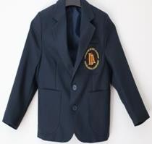 | SCHOOLWEAR SOLUTIONS OADBY,  64 London Rd, Oadby, Leicester LE2 5DH,  0116 2160665
Chequered Pinafore | 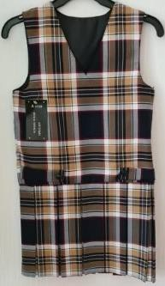 | MANSURI SCHOOLWEAR  Available from LIA for a limited period
Burgundy Cardigan | 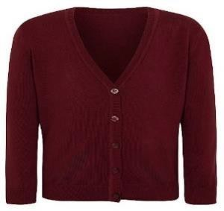 | ASDA  Girls Burgundy School Cardigan Single  Girls Burgundy School Cardigan 2 Pack  100% Cotton Button Fastening Lasting Colour

Girls White School Long Sleeve Shirt | 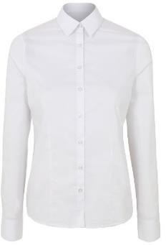 | ASDA
(Early Years Only) Black Plimsolls for indoor use | 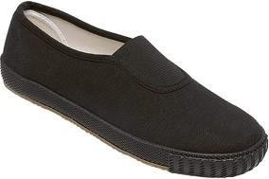 | Available at any supermarket or clothing store
Key Stage 1 & 2 | Head Scarf – White pull on hijab (Optional for Year 1 and Year 2)  Girl’s Abaya – Is unavailable at present however those wishing to wear an abayah instead of a pinafore please ensure it is grey
Additional Items | Black shoes – not to resemble sports trainers. Black tights  Navy school bag Navy coat  Homework bag – available from the school office

- Boys Uniform

Item |  | Available Suppliers
Classic dark navy blazer with school badge |  | SCHOOLWEAR SOLUTIONS OADBY,  64 London Rd, Oadby, Leicester LE2 5DH, 0116 2160665
Charcoal Regular School Trousers | 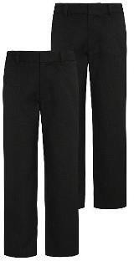 | ASDA  Boys Charcoal Regular Leg School Trouser 2 Pack  Flexi-waistband 2 front pockets Teflon® EcoElite Regular leg

Burgundy Jumper | 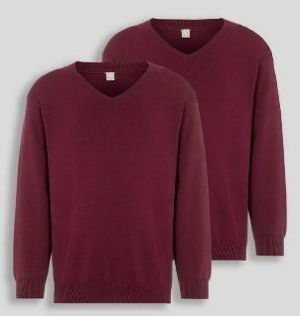 | ARGOS TU / Sainsburys TU Dark Red V-Neck Jumpers 2 Pack (tuc129087531)  Dark Read V-Neck Jumpers 2 Pack (Sainsburys)  Fine gauge knit
Boys White Long Sleeve School Shirt | 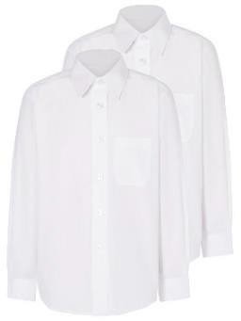 | ASDA
(Early Years Only) Black Plimsolls for indoor use |  | Available at any supermarket or clothing store
Key Stage 1 & 2 | Topi – white  Boys Jubba – Is unavailable at present however those wishing to wear a jubba must be grey
Additional Items | Black shoes – not to resemble sports trainers. Black tights  Navy school bag Navy coat  Homework bag – available from the school office

- PE Uniform

Girls | Boys
White trainers White socks  Black jogging bottoms  Black jogging sweatshirt (no hoodies) Drawstring bag  Early Years & Key Stage 1 - White short sleeved t-shirt  Key Stage 2 - White long-sleeved top | White trainers White socks  Black jogging bottoms  Black jogging sweatshirt (no hoodies) White T-Shirt  Drawstring bag

- Roles and Responsibilities
  - Governing Board
The Governing Body has:
    - delegated to the Headteacher the responsibility of implementing and maintaining this policy
    - delegated powers and responsibilities to the Headteacher to ensure all school personnel and visitors to the school are aware of and comply with this policy
    - responsibility for ensuring that the school complies with all equalities legislation
    - responsibility for ensuring this policy and all policies are maintained and updated regularly;
    - responsibility for ensuring all policies are made available to parents;
    - determining this policy with the Governing Body;
    - discussing improvements to this policy during the school year;
    - reviewing the effectiveness of this policy with the Governing Body
    - responsibility for the effective implementation, monitoring and evaluation of this policy

Headteacher
The Headteacher will:
    - delegate responsibility on its endorsement to the Senior Leadership Team
    - ensure all school personnel, pupils and parents are aware of and comply with this policy
    - ask all staff to report any pupil who does not comply with this policy
    - write to parents of pupils abusing this policy asking for their support before any further sanctions are imposed
    - impose sanctions for non-compliance with school uniform
    - process any complaints received in the appropriate way as stated in the school’s complaints
policy
    - make effective use of relevant research and information to improve this policy
    - work closely with the governors
    - provide leadership and vision in respect of equality
    - provide guidance, support and training to all staff
    - monitor the effectiveness of this policy by speaking with pupils, school personnel, parents and governors
    - regularly report to the Governing Body on the success and development of this policy

Staff
Staff will:
    - comply with all aspects of this policy
    - lead by example dressing appropriately
    - be of a neat and tidy appearance
    - report any pupil who does not comply with this policy
    - implement the school’s equalities policy and schemes
    - report and deal with all incidents of discrimination
    - attend appropriate training sessions on equality
    - report any concerns they have on any aspect of the school community

Pupils
Pupils will:
    - be aware of and comply with this policy by wearing correct uniform
    - be polite and well behaved at all times
    - show consideration to others
    - obey all health and safety regulations in all areas of the school
    - liaise with the school council about any improvements to this policy
    - take part in questionnaires and surveys

Parents/Carers
Parents/carers will:
    - be aware of and comply with this policy by ensuring their children wear school uniform at all times
    - be contacted if their child is not wearing the correct uniform;
    - ensure that their child's uniform is clean and good repair
    - support the school
    - be asked to take part periodic surveys conducted by the school

Non-Compliance with the Uniform Policy
It is the responsibility of all staff to ensure that the school uniform policy is adhered to. Parents and carers of pupils that do not wear the correct uniform will be contacted and asked to bring the correct uniform into school. If this is not possible then pupils will be provided with the correct item of uniform, they are missing for the day. Persistent and defiant non-compliance with the policy will result in an appropriate sanction.
There may be good reasons why a pupil is not wearing school uniform. In this case, parents and carers should share the reasons with the class teacher either in person or by letter. The school will always be considerate and discrete in trying to establish why a pupil is not wearing the correct uniform. Pupils will not be made to feel uncomfortable, nor discriminated against, because their parents are unable to provide them with the required items of school uniform.
There will be occasions when the school decides that school uniform is not appropriate e.g. when taking part in a physical activity day, wearing different clothes as a part of a fund-raising event or topic entry point activity day. Parents and carers will be notified in advance of the revised dress code on these days.

Naming Clothing and Property
Please ensure all clothing and property is clearly marked so that lost articles may be easily traced and returned. The school cannot accept responsibility for loss or damage of pupils’ property and valuables

Complaints
We have in place clear procedures to deal with any complaint made against the school or individuals connected with it. We take any complaint seriously and we deal with them professionally following set procedures.

Raising Awareness of this Policy
We will raise awareness of this policy via:
- the school website
- the Staff Handbook
- meetings with parents such as introductory, transition, parent-teacher consultations and periodic curriculum workshops
- school events
- meetings with school personnel
- communications with home
- information displays in the main school entrance

Monitoring Arrangements
This policy will be reviewed by the headteacher every year but can be revised earlier if required. At every review, the policy will be approved by the full governing board.

Links with Other Polices
This policy links with our:
- Equal Opportunities Policy
- Behaviour Policy
- Complaints Policy

